Treating Patient with Severe Sepsis/Septic Shock
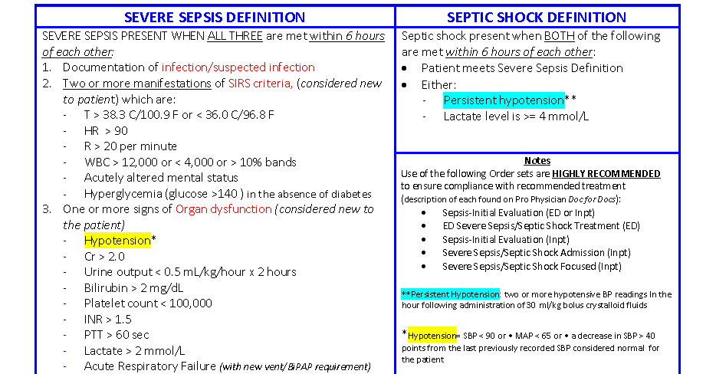
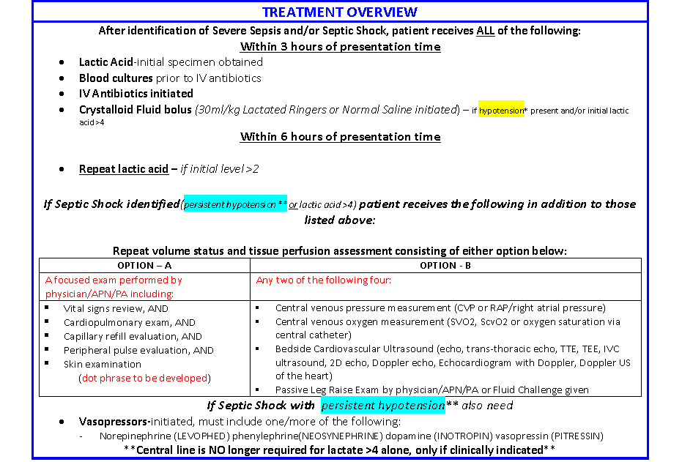

(Excludes patients who are under the age of 18, refuse treatment or are comfort measures only)

ED Workflow
Exclusions: Patients under the age of 18.
Patient presents to ED, chief complaint entered vital signs taken.
Vital Signs = SIRS criteria | Vital Signs ≠ SIRS criteria and Suspicion of Infection Screening has NOT been Completed
Upon entry of triage vital signs nurse or nursing students may see a BPA:  (Patient must have at least 2 criteria documented: T> 38.3; T< 36.0, HR >90; RR > 20, Glucose > 140 prior to arrival, mental status altered from baseline.)  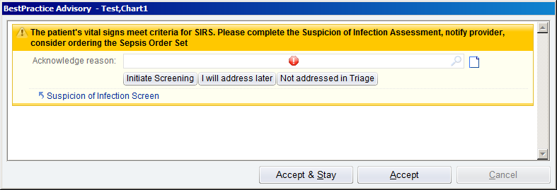  BPA ED SIRS Criteria (fires for nurses and nursing students only)  Possible actions:  - Nurse Initiates Screening choosing this acknowledgement button first then using the link to the Suspicion of Infection Screen will lock out the BPA for the current user for an hour. However if one clicks on the hyperlink first and completes Suspicion of Infection Screen -if the screening result is:  - YES this BPA will no longer fire as the screening has been completed;  - NO the system will fire the BPA for the current user for an hour, after an hour if the criteria are present it will fire again.  - I will address later – choosing this button will lock out the BPA for the current user for an hour.  - Not addressed in Triage – choosing this button will lock out the BPA for the current user for an hour  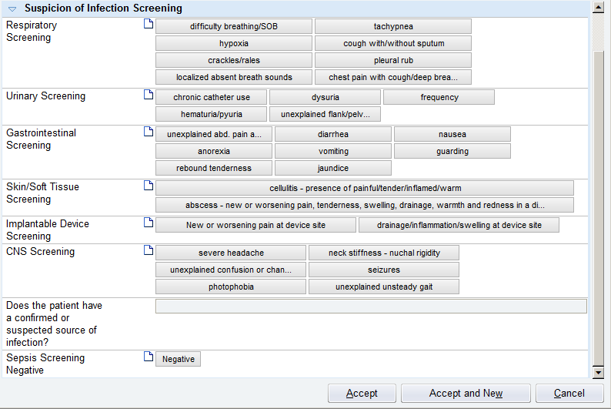  Suspicion of Infection Screen  Nurse reviews each of the screening rows:  - If patient has any of the symptoms listed; the final question “Does the patient have a confirmed or suspected source of infection?” autopopulates “Yes”. (The patient now has at least 2 of 3 criteria to define severe sepsis.) The nurse informs the provider, provider determines if patient has 3rd criteria (organ dysfunction) or if additional information is needed to confirm severe sepsis.  - If the screening does not result in any positive findings, the nurse documents Sepsis Screening as “Negative.”  The system will continue to assess patient’s information to see if SIRS criteria become present. (Patient must have 2 criteria documented: T> 38.3; T < 36.0 HR >90; RR > 20; a glucose or POCT glucose > 140 within the last 12 hours; a pre-arrival glucose documented as > 140; mental status is altered from baseline; along with a suspicion of infection screen not performed or documented as negative more than one hour ago.)  If so the system will display the BPA to trigger a rescreen for suspicion of infection.  BPA ED SIRS Criteria (fires for nurses and nursing students only) | The triage nurse may indicate mental status altered from baseline using the Sepsis Screening section located in the ESI section of the Triage Navigator:  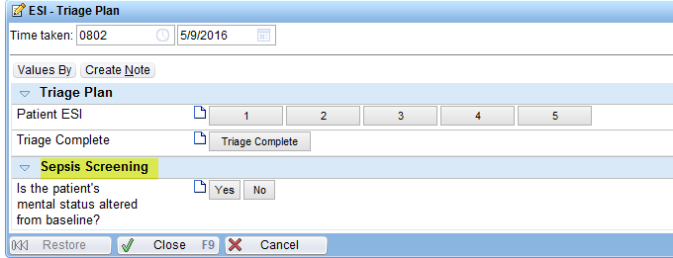  The system will continue to assess patient’s information to see if SIRS criteria are met. (Patient must have 2 criteria documented: T> 38.3; T < 36.0 HR >90; RR > 20; a glucose or POCT glucose > 140 within the last 12 hours; a pre-arrival glucose documented as > 140; mental status is altered from baseline.)  If criteria are met the following BPA will display:  BPA ED SIRS Criteria (fires for nurses and nursing students only)  Note: At any time during the patient encounter the nurse may document a Suspicion of Infection Screen from the ED narrator screening section:  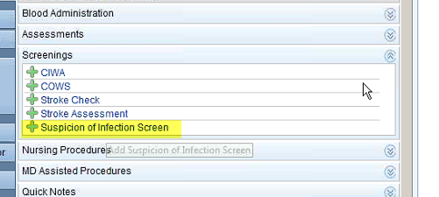  Suspicion of Infection Screen
Provider ready to see patient
Provider accesses patient chart. If patient has at least 2 criteria documented: T> 38.3; T < 36.0; HR >90; RR > 20; a glucose or POCT glucose > 140 within the last 12 hours; a pre-arrival glucose documented as > 140; mental status is altered from baseline; WBC < 4 or > 12 within the last 12 hours or > or = to 10 % bands + segmented neutrophils; AND the meets severe sepsis screen has not been marked “Yes” today. The BPA presents:  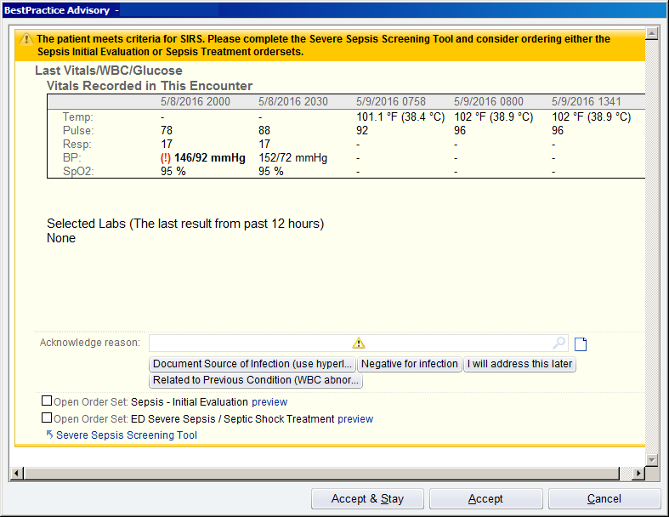  BPA Provider SIRS with Labs Criteria (fires for MD, PA, NPs only)  The BPA displays the patient’s most recent vital signs in the far right column. If the patient has any lab values these too would display.  Possible Actions:  - If the patient requires orders to be placed right away, the provider can bypass an acknowledgement reason and proceed to select the appropriate order set (place a checkmark in the appropriate box) then click accept. The selected order set will open.  - Document source of infection –select the similarly named acknowledgement button then use the hyperlink to complete the Sepsis Screening.  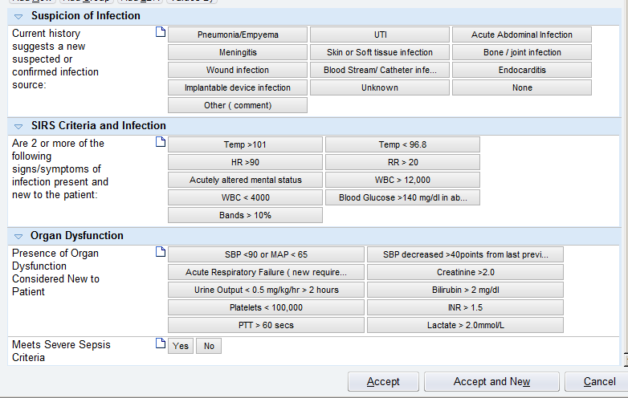  Severe Sepsis Screen  2. Negative for infection -suppresses the BPA from firing for all users for 1 hour – (proceed to Not Sepsis column below)  3. I will address later – suppresses the BPA for all users for 1 hour.  4. Related to previous condition (WBC abnormal) - suppresses the BPA for the current user for 1 hour. (proceed to Not Sepsis column below) | Nursing entry of Sepsis Screening will appear on the ED Patient Care Timeline:  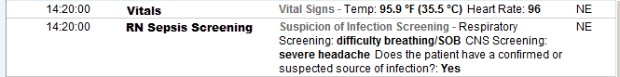  ED Patient Care Timeline  Also at any time the Provider may perform a sepsis screen by using the Tool Bar icon:  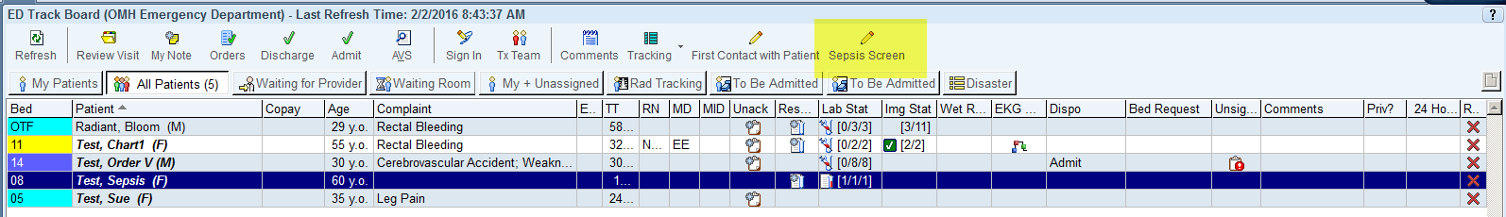  Sepsis Screen Icon
Provider assessment completed – 3 potential pathways
Patient meets Severe Sepsis definition (will begin treatment right away) | Patient may have Severe Sepsis (need more information, ie labs to confirm) | Not Sepsis.  The system will continue to assess patient’s information to see if SIRS criteria are met.  Must have 2 criteria: T> 38.3; T < 36.0 HR >90; RR > 20; a glucose or POCT glucose > 140 within the last 12 hours; a pre-arrival glucose documented as > 140; mental status is altered from baseline.). BPA ED SIRS Criteria  Must have 2 criteria: T> 38.3; T < 36.0; HR >90; RR > 20; a glucose or POCT glucose > 140 within the last 12 hours; a pre-arrival glucose documented as > 140; mental status is altered from baseline; WBC < 4 or > 12 within the last 12 hours; AND the meets severe sepsis screen has not been marked “Yes” today. BPA Provider SIRS Criteria  Patient is treated for non-severe sepsis presenting condition.

Provider determines treatment approach based on patient vital signs (especially blood pressure) and physical assessment.
Patient meets Severe Sepsis definition (will begin treatment right away) |  | Patient may have Severe Sepsis (need more information, ie labs to confirm)
Patient Hypotensive | Patient NOT hypotensive | Patient Hypotensive | Patient Not Hypotensive
Places Sepsis Initial Evaluation and ED Severe Sepsis/Septic Shock Treatment Order Sets, includes:  - 30 ml/kg bolus  - initial and repeat lactate  - blood cultures  - antibiotics  Nurse starts bolus  labs drawn  antibiotics started | Places Sepsis Initial Evaluation and ED Severe Sepsis/Septic Shock Treatment Order Sets, includes:  - initial and repeat lactate  - blood cultures  - antibiotics  labs drawn  antibiotics started | Places Sepsis Initial Evaluation order set includes:  - 30 ml/kg bolus  - initial and repeat lactate  - blood cultures  Nurse starts bolus  labs drawn | Places Sepsis Initial Evaluation order set includes:  - initial and repeat lactate  - blood cultures  labs drawn
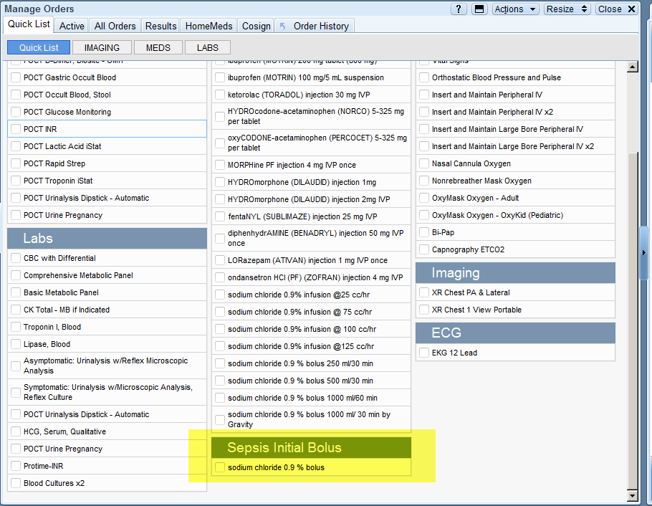
Note: Provider can place 30 mg/kg bolus and labs from preference lists, quick list or order set. The order sets assemble all potential orders into a single location. Antibiotics should be placed from the order set to assure the proper selection is made based on the source of infection (the quick list antibiotic selections are not able to display the necessary combination therapy required for treatment of the various sepsis sources).
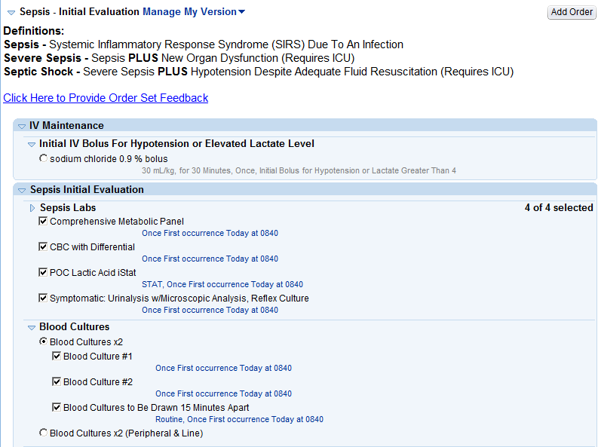

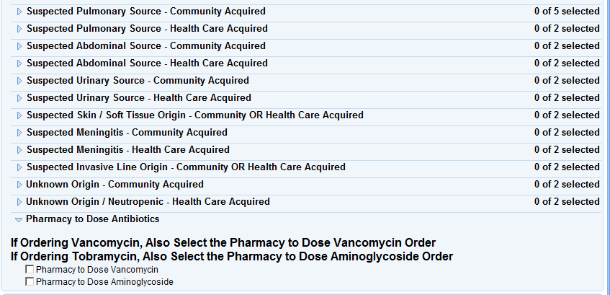
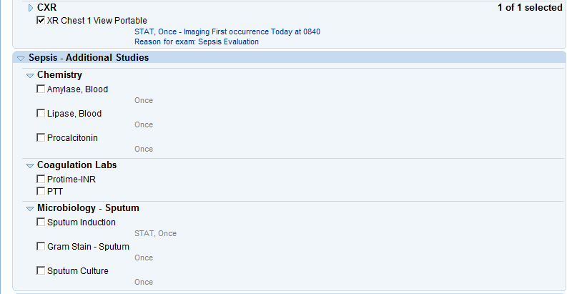

Sepsis Initial Evaluation Order Set Antibiotic portion of the ED Severe Sepsis/Septic Shock Treatment order set
Labs are obtained, results are received and reviewed, and the Provider determines appropriate actions. If Provider confirms severe sepsis and/or septic shock (confirmation timing varies) it can be documented as Severe Sepsis Present using Sepsis Screen Icon. Patient blood pressure remains a key determinant in treatment approach.
Initial Lactate > 4  Severe Sepsis with  Septic Shock Present |  | Initial Lactate < 4 |  | Initial Lactate > 4  Severe Sepsis with  Septic Shock Present |  | Initial Lactate < 4 |  | Initial Lactate > 4  Severe Sepsis with  Septic Shock Present |  | Initial Lactate < 4 |  | Initial Lactate > 4  Severe Sepsis with  Septic Shock Present |  | Initial Lactate < 4
Normo  tensive | Persistent  Hypotension | Normo  tensive  Severe Sepsis present | Persistent  Hypo-tension  Severe Sepsis with Septic Shock Present | Normo  tensive | Hypo-tension | Normo  tensive  Severe Sepsis present | Hypo-  tension  Severe Sepsis present | Normo  tensive | Persistent  Hypo-tension | Normo-tensive  Severe Sepsis present | Persistent  Hypo-tension  Severe Sepsis with Septic Shock Present | Normo  tensive | Hypo-tension | Normo  Tensive  Severe Sepsis present | Hypo-tension  Severe Sepsis present
 | Place Sepsis Pressor  Order Set – include CVP and SVO2 monitoring  Provider document focused exam |  | Place Sepsis Pressor  Order Set – includes CVP and SVO2 monitoring  Provider document focused exam |  | Place  30 ml/kg bolus  Reassess  Persistent Hypotension  Place Sepsis Pressor Order Set – includes CVP and SVO2 monitoring  Provider document focused exam |  | Place  30 ml/kg  bolus  Reassess  Persistent Hypotension  Severe Sepsis with Septic  Shock Present  Place Sepsis Pressor  Order Set – includes CVP and SVO2 monitoring  Provider document focused exam | Provider orders  Antibiotic ED Severe Sepsis Septic Shock Treatment order set | Provider orders  Antibiotic  ED Severe Sepsis  Septic  Shock Treatment order set  Place Sepsis Pressor Order Set – includes CVP and SVO2 monitoring  Provider document focused exam | Provider orders  Antibiotic  ED Severe Sepsis  Septic  Shock Treatment order set | Provider orders  Antibiotic  ED Severe Sepsis  Septic  Shock Treatment order set  Place Sepsis Pressor  Order Set – includes CVP and SVO2 monitoring  Provider document focused exam | Provider  orders  Antibiotic  ED Severe Sepsis  Septic  Shock Treatment order set | Provider orders  Antibiotic  ED Severe  Sepsis  Septic  Shock Treatment order set  Place  30 ml/kg  bolus  Reassess  Persistent Hypotension  Place Sepsis Pressor  Order Set – includes CVP and SVO2 monitoring  Provider document focused exam | Provider orders  Antibiotic  ED Severe Sepsis  Septic  Shock Treatment order set | Provider  orders  Antibiotic  ED Severe Sepsis  Septic  Shock Treatment order set  Place  30 ml/kg  bolus  Reassess  Persistent Hypotension  Severe Sepsis with Septic Shock Present  Place Sepsis Pressor  Order Set – includes CVP and SVO2 monitoring  Provider document focused exam
Provider continues to place appropriate orders.
If vasopressors are necessary the Severe Sepsis/Septic Shock Initiate Vasopressors order set may be used.
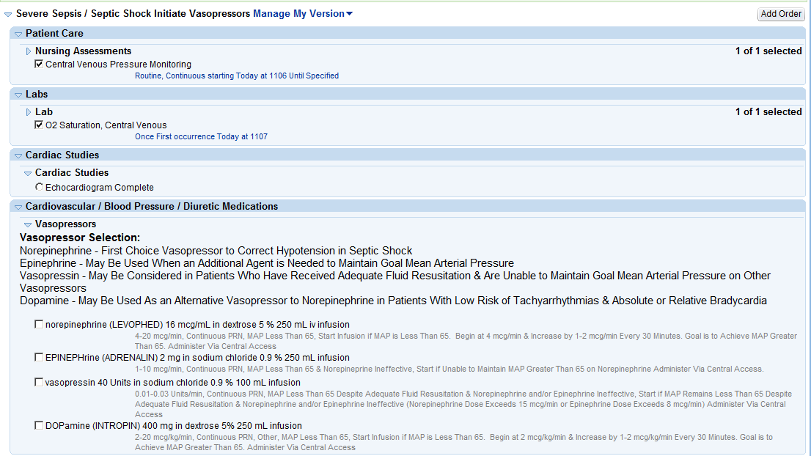
Severe Sepsis/Septic Shock Initiate Vasopressors
Nursing will administer fluid/medications and continue to assess patient.
Patients who proceed to Septic Shock and have persistent hypotension must have repeat volume status and tissue perfusion assessment documented by either and MD or IAHP. The documentation may consist of either:
- A focused exam including:
  - Vital signs review
  - Cardiopulmonary exam
  - Capillary refill evaluation
  - Skin examination
- Any 2 of the following four:
  - Central venous pressure measurement (CVP or right atrial pressure)
  - Central venous oxygen measurement (SVO2, ScvO2 or oxygen saturation via central catheter)
  - Bedside Cardiovascular Ultrasound (Echocardiogram complete (also known as TTE, trans-thoracic echo, 2D Echo, Doppler), Echocardiogram Transesophageal (also known as TEE)
  - Passive leg raise exam or fluid challenge given.
To document this assessment access the Focused Assessment under More Activities:
The focused assessment will open in the sidebar – the provider may complete either section to meet the requirements.
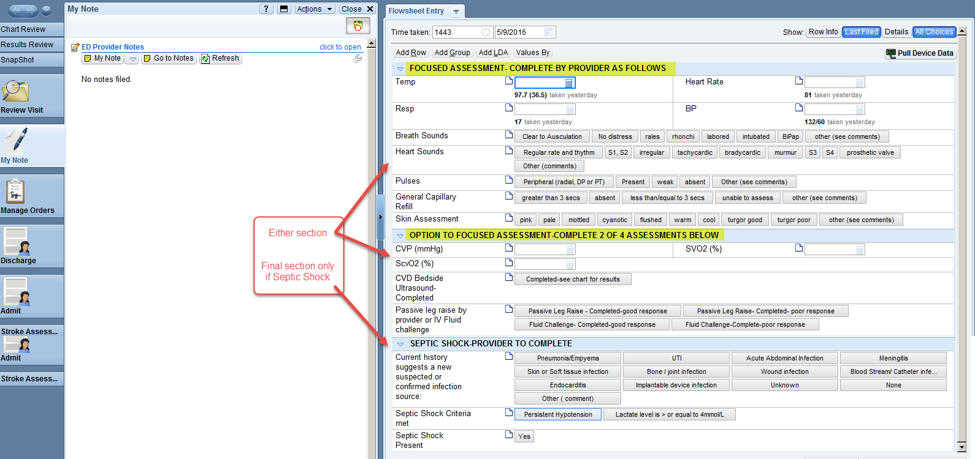

At any time the nurse or provider can utilize reports to review patient progress:
The Sepsis Summary report contains several widgets including patient medications, vital signs, select labs and imaging:
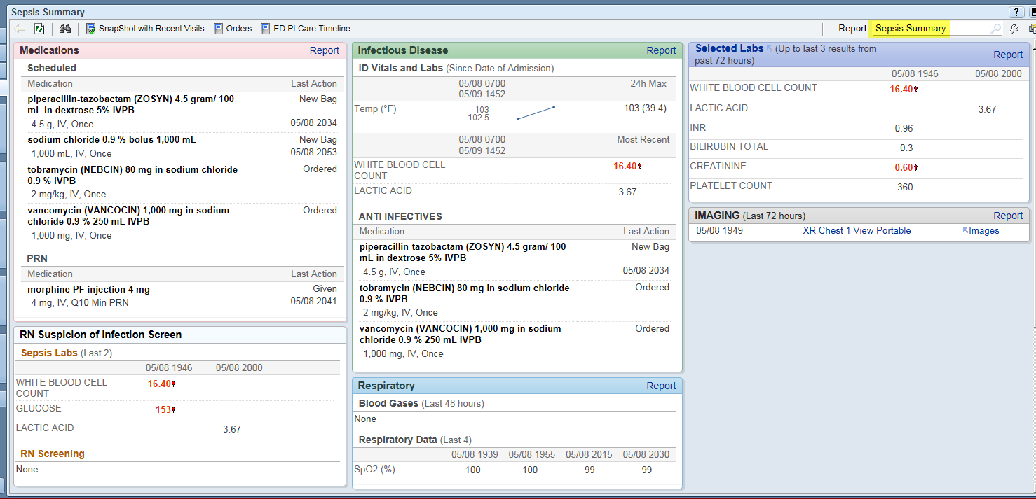
Sepsis Overview Report
Patients may be admitted at any point in the care process based on their needs, the admission process occurs per the usual fashion. Handoff communication should include appropriate information for both provider and nurse assuming care to continue necessary treatment for patient and assure treatment is completed within defined timeframes.

Note: If ED technicians are asked to obtain vitals and the patient has not had the suspicion of infection screening performed, they may encounter the following BPA:
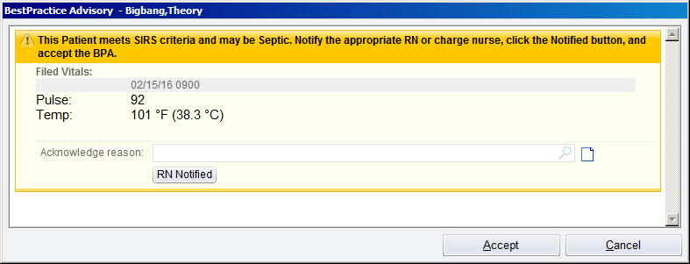
BPA ED Tech Screening (fires for ED technicians only)
The BPA fires when any 2 of the following criteria are present: T> 38.3; T < 36.0 HR >90; RR > 20; within the last 12 hours a glucose or POCT glucose > 140; a pre-arrival glucose documented as > 140; mental status is different than baseline. Thus documenting a new set of vitals may result in the BPA firing. After receiving the BPA the ED technician should select the RN notified button and proceed to notify the patient’s nurse or charge nurse. If the BPA fires and the ED technician acknowledges, a lock out time has been set for one hour for the current user. (The technician acknowledging the alert will not see this BPA again for one hour; other technicians who interact with the patient record to document flowsheet information would also see the BPA.)

Inpatient Workflow
Exclusions: Staff will not receive the BPA alerts:
- For patients whose location is in any of the following departments pre procedure, GI, Day Surgery, PACU, Perioperative or Anesthesia
- For patients whose location is any of the radiology imaging departments (CT, Nuc Med, MRI, Ultrasound, Diagnostic or Interventional Radiology)
- For patients at AngelsGrace Hospice
- For patients receiving only Comfort Measure treatment – must have a Comfort Measure order in their current encounter (its order status will be listed as complete)
- For patients under the age of 18.
Patient admitted to inpatient unit from the ED without Severe Sepsis OR admitted as direct admit OR becomes septic during admission.
Patient care technicians who take patient vital signs will receive a BPA upon saving the documentation of a patient’s vital signs if 2 of the following SIRS criteria are present: within the past 2 hours: T > or = 38.3; T < or = 36.0 HR >or = 90; RR > or = 21; WBC within the last 24 hours that is > or = 12; < or = 4; or > or = 10 % bands +segmented neutrophils.
Patient care technicians should notify the patient’s RN or charge nurse that the patient has the SIRS criteria, then document the acknowledgement reason, indicating they have notified the RN, then click accept. Acknowledgement of the BPA will result in a suppression of additional alerts for the next 3 hours for that technician only.
BPA Patient Care Technician (fires for inpatient patient care technicians only)
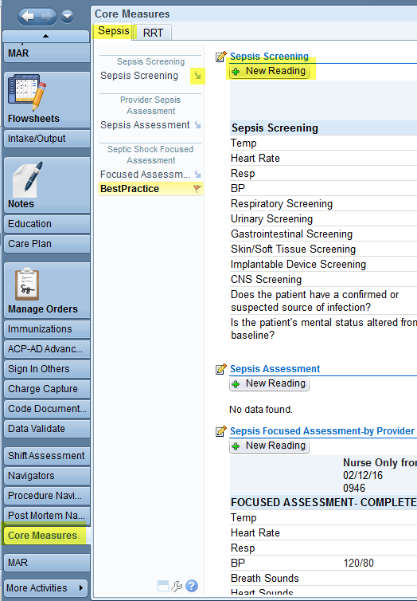
Patient does not have SIRS criteria
The system will assess information documented in the patient’s chart whenever 2 or more criteria are present the BPA will fire.
Must have 2 criteria: within the past 2 hours: T >or = 38.3; T < or = 36.0 HR >or = 90; RR > or = 21; WBC within the last 24 hours that is > or = 12; < or = 4; or > or = 10 % bands +segmented neutrophils AND does not have a Sepsis diagnosis on their problem list. See BPA IP Sepsis Risk (fires only to nurses and nursing students). Note: The BPA is unable to trigger for either a recent change in the patient’s mental status or a recent glucose level > 140 in a non-diabetic.
Additionally the nurse can perform a sepsis screening at any point during the visit by accessing either the Sepsis Documentation Flowsheet OR the Sepsis Navigator located in the Core Measure Activity

Sepsis Tab in Core Measure Navigator
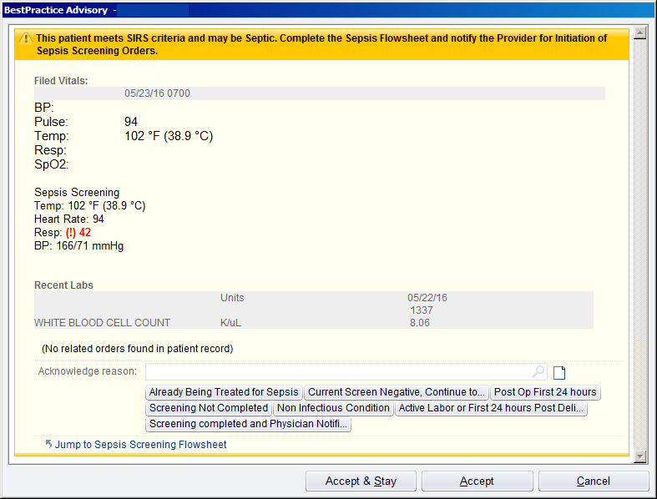
Patient has SIRS criteria
A nurse may receive a BPA upon opening the patient chart, saving flowsheet documentation, or when reviewing the BPA section of a navigator if the patient has at least 2 of the following criteria: Within the past 2 hours: T >or = 38.3; T < or = 36.0 HR > or = 90; RR > or = 21 ; WBC within the last 24 hours that is > or = 12; < or = 4; or > or = 10 % bands + segmented neutrophils AND does not have a Sepsis diagnosis on their problem list.
Note: The BPA is unable to trigger for either a recent change in the patient’s mental status or a recent glucose level > 140 in a non-diabetic.

Nurse evaluates the alert and the data presented; the nurse then takes action:
The nurse should evaluate whether the patient meets one of the 4 choices to suppress the BPA: BPA IP Sepsis Risk (fires only to nurses and nursing students)
  - Already Being Treated for Sepsis – choose this option for the patient who is already being treated for sepsis. The BPA will suppress for 24 hours for all nurses and nursing students.
  - Post Op patient within the first 24 hours – choose this option for the patient who underwent surgery within the last 24 hours, a patient’s vital signs in the 24 hours immediately post-op may mimic those seen in a patient with severe sepsis. The BPA will suppress for 24 hours for all nurses and nursing students. This selection should not be used on patient’s more than 24 hours post op.
  - Non-Infectious Condition – choose this option If the patient has a pre-existing condition that explains the SIRS criteria, the nurse must evaluate the information presented in the BPA and determine if further sepsis work up is required or if the patient’s existing condition is the reason for the criteria. Accepting this choice will suppress the BPA for 24 hours for all nurses and nursing students.
  - Active Labor or Within First 24 hours Post Delivery – choose this option if the patient is actively in labor or is within the first 24 hours post-delivery. A patient’s vital signs during active labor and in the first 24 hours post-delivery may mimic those seen in a patient with serve sepsis. The BPA will suppress for 24 hours for all nurses and nursing students. This selection should only be used on patients who are in active labor or delivered within the last 24 hours.
- If not the nurse can indicate:
  - Screening Not Completed – choose this option if you are unable to complete the screening now; the BPA will fire again in an hour to prompt you to complete it.
OR
- Jump to the Sepsis Screening Flowsheet without using one of the acknowledgement buttons, in this case the BPA will fire again upon filing the sepsis screening, allowing the nurse to acknowledge the BPA and complete the necessary assessment.

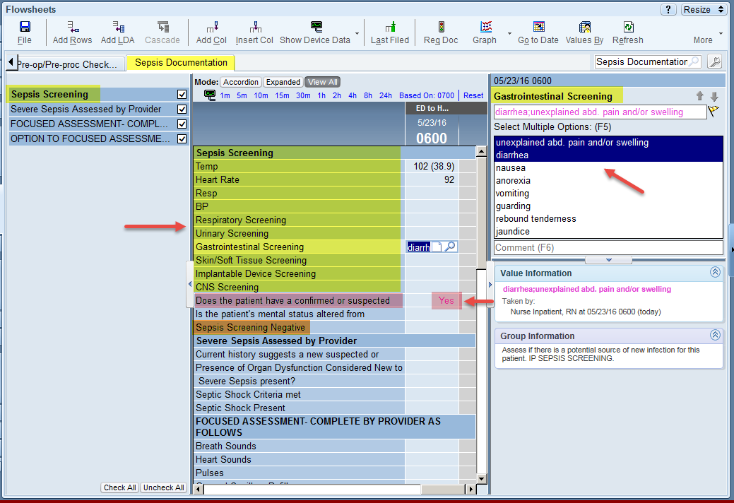
When jumping to the flowsheet the Nurse is to concentrate on the Sepsis Screening rows of the flowsheet:
The vital signs may have been completed by the CNA; the nurse may obtain a repeat set if desired.
The various screening rows should be evaluated: the selections available are symptoms that are commonly present with severe sepsis.
If any of the symptoms in any of the screening rows is selected: the row labeled “Does the patient have a confirmed or suspected source of infection?” will automatically populate with a Yes answer.
If the patient does not have any symptoms of sepsis; the nurse documents in the row labeled Sepsis Screen Negative.
Finally, indicate if the patient’s mental status is altered from baseline. Sepsis Documentation Flowsheet
Upon filing the sepsis screening documentation; if the nurse did not acknowledge the BPA it will present again. The nurse can now select the appropriate choice based on her screening results.
  - Current Screen Negative, Continue to Surveil –choose this option for the patient whose sepsis screening was negative. The BPA will suppress for 8 hours for the current nurse/nursing student.
  - Screening Completed and Physician Notified – Choose this option if the screening has been completed and the physician has been notified select this response to suppress the BPA for 8 hours for all nurses and nursing students.
The nurse notifies the provider whether the sepsis screening was positive or negative.
A positive screen means the patient now has 2 of the 3 criteria necessary to be considered in severe sepsis:
- 2 or more SIRS criteria (those values that presented in the BPA)
AND
- The patient has a possible source of infection
A negative screen means the nurse was unable to determine if the patient has a possible source of infection. The patient still has 2 or more SIRS criteria (those values that presented in the BPA).
Provider takes one of 2 approaches:
Continue Current Plan of Care
Nurse continues to care for patient, observe for changes. Nurse will receive additional BPAs (once suppression time has passed), if patient meets the SIRS criteria the BPA will look for vital signs and labs; whenever 2 or more of the criteria are present:
See BPA IP Vitals for screen shot.
Must have 2 criteria: within the past 2 hours: T >or = 38.3; T < or = 36.0 HR >or = 90; RR > or = 21; WBC within the last 24 hours that is > or = 12; < or = 4; or > or = 10 % bands +segmented neutrophils AND does not have a Sepsis diagnosis on their problem list. Note: The BPA is unable to trigger for either a recent change in the patient’s mental status or a recent glucose level > 140 in a non-diabetic.
The nurse can perform a sepsis screening at any point during the visit by accessing either the Sepsis Documentation Flowsheet OR the Sepsis Navigator located in the Core Measure Activity
Sepsis Documentation Flowsheet or Sepsis Tab in Core Measure Navigator
Further Action Required
Provider needs to determine if patient has 3rd criteria Organ Dysfunction. Provider may ask nurse more questions, may screen/assess patient, and may order/give telephone order for additional tests.
If Provider is not in the hospital the Nurse should be prepared for possible telephone orders for a Sepsis work up; the Nurse can pull up the Sepsis Evaluation order set and share/inform the provider of its contents for consideration in ordering.
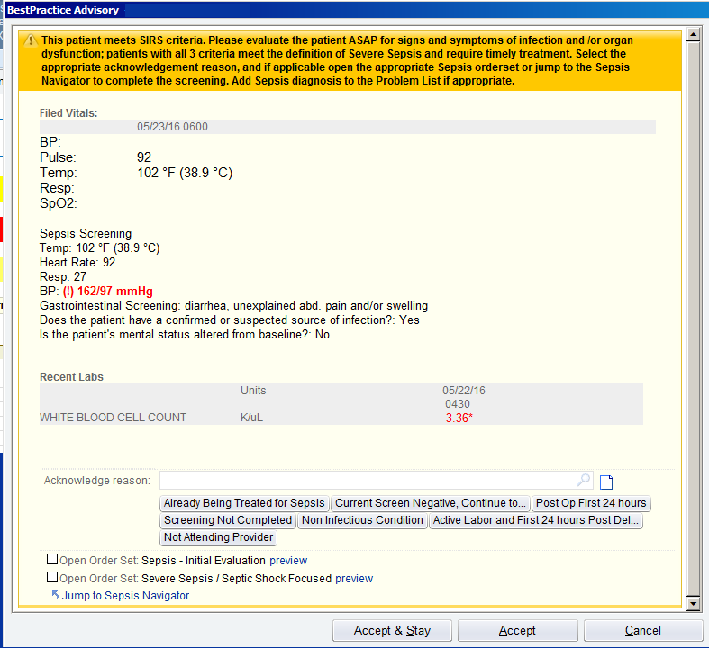
If the Provider is in the hospital, a BPA may be presented if at least 2 of the following criteria exist: within the past 2 hours: T >or = 38.0; T < or = 36.0 HR >or = 90; RR > or = 21; WBC within the last 24 hours that is > or = 12; < or = 4; or > or = 10 % bands + segmented neutrophils AND the patient has a suspected source of infection documented by the nurse within the last 2 hours AND does not have a Sepsis diagnosis on their problem list.

The provider evaluates whether the patient meets one of the 4 choices to suppress the BPA:
- Already Being Treated for Sepsis – choose this option for the patient who is already being treated for sepsis. The BPA will suppress for 24 hours for all providers (MD, PA, and NP) and medical students.
  - Post Op patient within the first 24 hours – choose this option for the patient who underwent surgery within the last 24 hours, a patient’s vital signs in the 24 hours immediately post-op may mimic those seen in a patient with severe sepsis. The BPA will suppress for 24 hours for all providers (MD, PA, and NP) and medical students. This selection should not be used on patient’s more than 24 hours post op. BPA IP Provider
- Non-Infectious Condition – choose this option If the patient has a pre-existing condition that explains the SIRS criteria, the nurse must evaluate the information presented in the BPA and determine if further sepsis work up is required or if the patient’s existing condition is the reason for the criteria. Accepting this choice will suppress the BPA for 24 hours for all providers (MD, PA, and NP) and medical students.
- Active Labor or Within First 24 hours Post Delivery – choose this option if the patient is actively in labor or is within the first 24 hours post-delivery. A patient’s vital signs during active labor and in the first 24 hours post-delivery may mimic those seen in a patient with serve sepsis. The BPA will suppress for 24 hours for all providers (MD, PA, and NP) and medical students. This selection should only be used on patients who are in active labor or delivered within the last 24 hours.
If not the provider can indicate:
- Screening Not Completed – choose this option if you are unable to complete the screening now; the BPA will fire again in an hour to prompt you to complete it.
OR
- Jump to the Sepsis Navigator without using one of the acknowledgement buttons, in this case the BPA will fire again upon filing the sepsis navigator, allowing the provider to acknowledge the BPA and complete the necessary assessment.
OR
- Select an order set to open: Sepsis Initial Evaluation or Severe Sepsis / Septic Shock Focused.
If the provider chooses to Jump to the Sepsis Navigator, the provider will see the documentation performed by nursing:
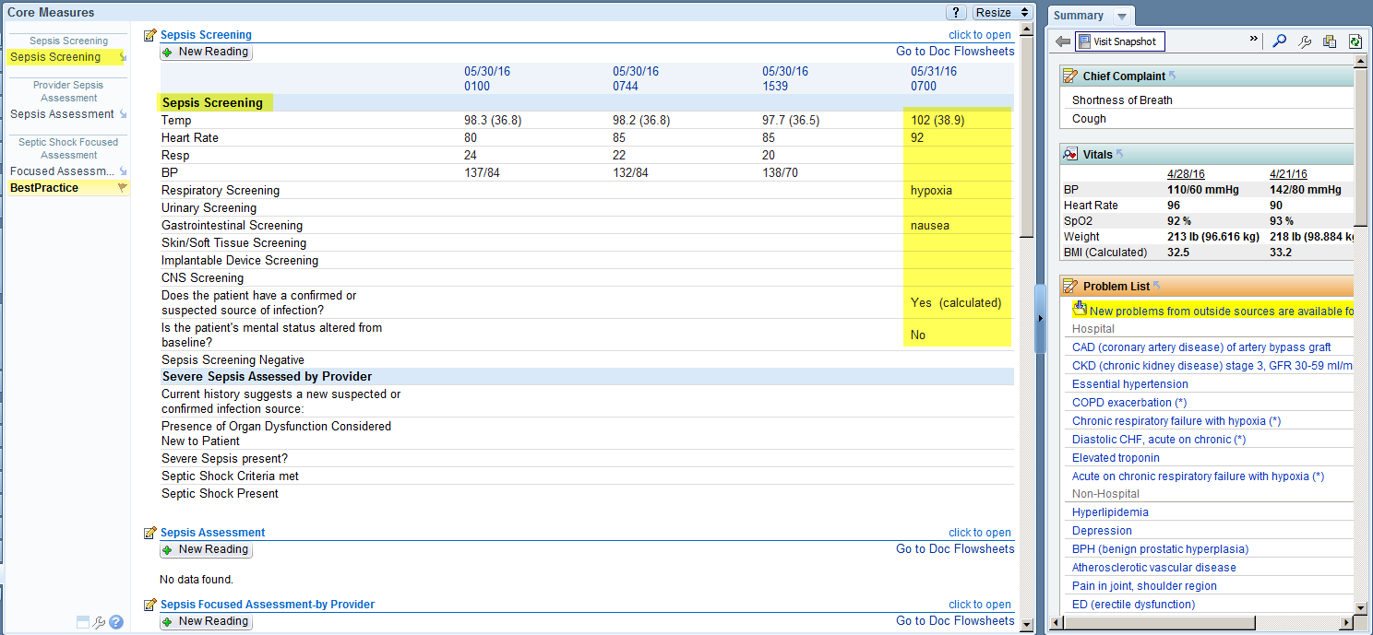
Sepsis Navigator Activity found in the Core Measure Navigator
The Provider assesses the patient and then documents his assessment by clicking on the words “Sepsis Assessment,” it is helpful to have the All Choices selection turned on (top right corner). At this point the provider is documenting whether the patient has a suspected or confirmed source of infection; and whether there is any new organ dysfunction (both of which are criteria necessary for severe sepsis).
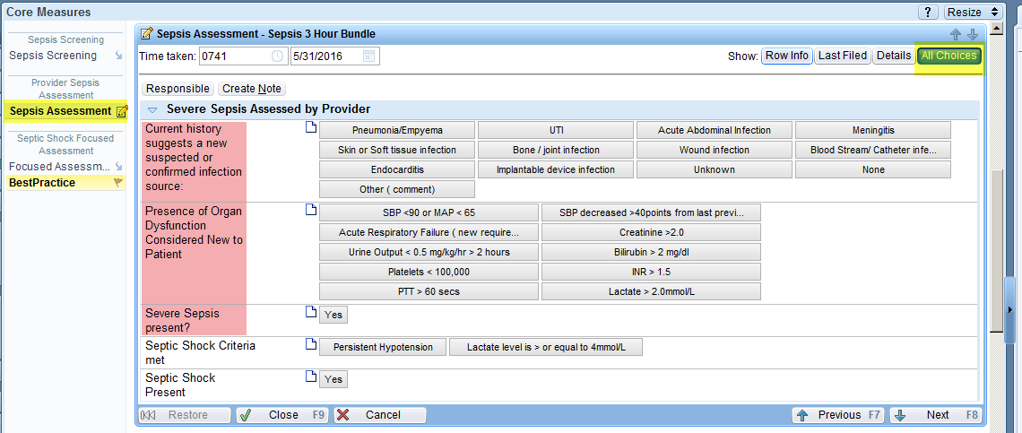
Sepsis Navigator Activity found in the Core Measure Navigator
If the patient also has either persistent hypotension (according to the sepsis definition) or a lactate level >/= to 4 mmol/L; the patient would meet the criteria for Septic Shock and those questions can be answered (highlighted in pink).
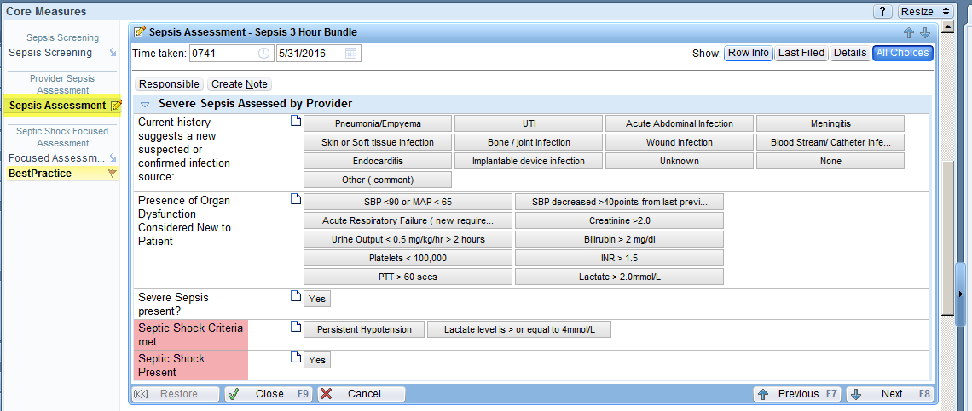
Sepsis Navigator Activity found in the Core Measure Navigator
The Provider can now complete the BPA by clicking on the Best Practice section to redisplay the BPA then select the appropriate acknowledgement or action:
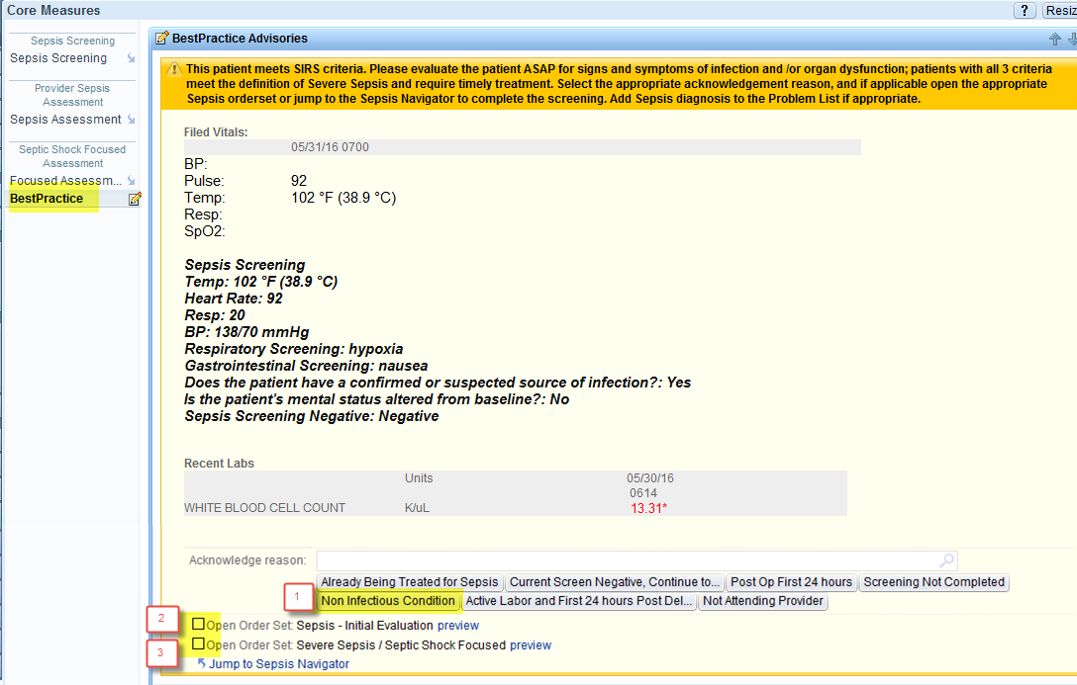
The Provider’s assessment results in 1 of 3 pathways:
- Patient does not meet criteria – Not Infection Criteria is selected. Accepting this choice will suppress the BPA for 24 hours for all providers (MD, PA, and NP) and medical students. Patient is treated for non-severe sepsis presenting condition.
- Patient may have severe sepsis, additional information is needed- Sepsis Initial Evaluation order set can be placed.
- Patient meets criteria – Severe Sepsis / Septic Shock Focused order set can be placed.

Patient may have Severe Sepsis (need more information, ie labs to confirm) |  | Patient meets Severe Sepsis definition (will begin treatment right away)
Patient Hypotensive | Patient Not Hypotensive | Patient Hypotensive | Patient NOT hypotensive
Places Sepsis Initial Evaluation order set includes:  - 30 ml/kg bolus  - initial and repeat lactate  - blood cultures  Nurse starts bolus  labs drawn | Places Sepsis Initial Evaluation order set includes:  - initial and repeat lactate  - blood cultures  labs drawn | Places Sepsis Initial Evaluation and Severe Sepsis/ Septic Shock Focused Order Sets, includes:  - 30 ml/kg bolus  - initial and repeat lactate  - blood cultures  - antibiotics  Nurse starts bolus  labs drawn  antibiotics started | Places Sepsis Initial Evaluation and Severe Sepsis/ Septic Shock Focused Order Sets, includes:  - initial and repeat lactate  - blood cultures  - antibiotics  labs drawn  antibiotics started
Note: Provider can place 30 mg/kg bolus and labs from preference lists or order set. The order sets assemble all potential orders into a single location. Antibiotics should be placed from the order set to assure the proper selection is made based on the source of infection.

Sepsis Initial Evaluation Order Set Antibiotic portion of the Severe Sepsis/Septic Shock Focused/Admission order set
Labs are obtained, results are received, and the Provider reviews and determines appropriate actions. If Provider confirms severe sepsis and/or septic shock (confirmation timing varies) it can be documented as Severe Sepsis Present in the Sepsis Navigator.
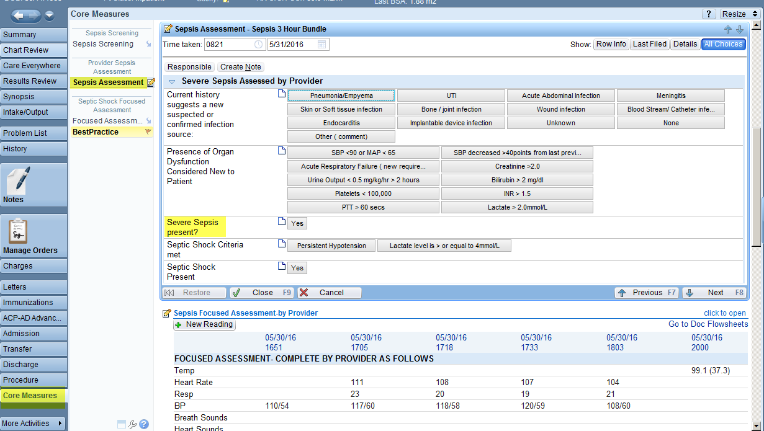
Sepsis Navigator Activity found in the Core Measure Navigator- Sepsis Assessment
Patient’s lactate level and blood pressure remain keys to determine treatment approach.
Initial Lactate > 4  Severe Sepsis with  Septic Shock Present |  | Initial Lactate < 4 |  | Initial Lactate > 4  Severe Sepsis with  Septic Shock Present |  | Initial Lactate < 4 |  | Initial Lactate > 4  Severe Sepsis with  Septic Shock Present |  | Initial Lactate < 4 |  | Initial Lactate > 4  Severe Sepsis with  Septic Shock Present |  | Initial Lactate < 4
Normo  tensive | Persistent  Hypotension | Normo  tensive  Severe Sepsis present | Persistent  Hypo-tension  Severe Sepsis with Septic Shock Present | Normo  tensive | Hypo-tension | Normo  tensive  Severe Sepsis present | Hypo-  tension  Severe Sepsis present | Normo  tensive | Persistent  Hypo-tension | Normo-tensive  Severe Sepsis present | Persistent  Hypo-tension  Severe Sepsis with Septic Shock Present | Normo  tensive | Hypo-tension | Normo  Tensive  Severe Sepsis present | Hypo-tension  Severe Sepsis present
 | Place Sepsis Pressor  Order Set – include CVP and SVO2 monitoring  Provider document focused exam |  | Place Sepsis Pressor  Order Set – includes CVP and SVO2 monitoring  Provider document focused exam |  | Place  30 ml/kg bolus  Reassess  Persistent Hypotension  Place Sepsis Pressor Order Set – includes CVP and SVO2 monitoring  Provider document focused exam |  | Place  30ml/kg  bolus  Reassess  Persistent Hypotension  Severe Sepsis with Septic  Shock Present  Place Sepsis Pressor  Order Set – includes CVP and SVO2 monitoring  Provider document focused exam | Provider orders  Antibiotic Severe Sepsis  Septic Shock Focused order set | Provider orders  Antibiotic Severe  Sepsis  Septic  Shock Focused order set  Place Sepsis Pressor Order Set – includes CVP and SVO2 monitoring  Provider document focused exam | Provider orders  Antibiotic Severe  Sepsis  Septic  Shock Focused order set | Provider orders  Antibiotic Severe  Sepsis  Septic  Shock Focused order set  Place Sepsis Pressor  Order Set – includes CVP and SVO2 monitoring  Provider document focused exam | Provider  orders  Antibiotic Severe  Sepsis  Septic  Shock  Focused  order set | Provider orders  Antibiotic Severe  Sepsis  Septic  Shock  Focused  order set  Place  30 ml/kg  bolus  Reassess  Persistent Hypotension  Place Sepsis Pressor  Order Set – includes CVP and SVO2 monitoring  Provider document focused exam | Provider orders  Antibiotic Severe  Sepsis  Septic  Shock Focused order set | Provider  orders  Antibiotic Severe  Sepsis  Septic  Shock  Focused  order set  Place  30 ml/kg  bolus  Reassess  Persistent Hypotension  Severe Sepsis with Septic Shock Present  Place Sepsis Pressor  Order Set – includes CVP and SVO2 monitoring  Provider document focused exam
Provider continues to place appropriate orders based on patient needs including the 3 hour and 6 hour treatment requirements for sepsis.
Providers order a conditional Lactic Acid Level, which must be performed only if the prior value one was greater than 2.
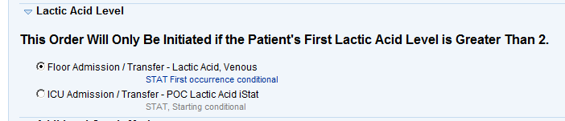
When the lactic acid result comes back, if the result is greater than 2, the nurse will see the following BPA:
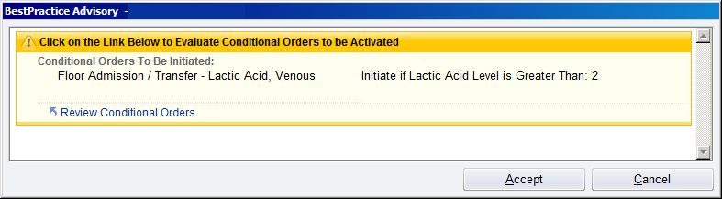
Click on the Review Conditional Orders Link to be taken to the conditional orders queue:
Locate the desired conditional order then select Initiate to activate the order.

If vasopressors are necessary the Severe Sepsis/Septic Shock Initiate Vasopressors order set may be used.
Severe Sepsis/Septic Shock Initiate Vasopressors
Nursing will administer fluid/medications and continue to assess patient.
Patients who proceed to Septic Shock and have persistent hypotension must have repeat volume status and tissue perfusion assessment documented by either and MD or IAHP. The documentation may consist of either:
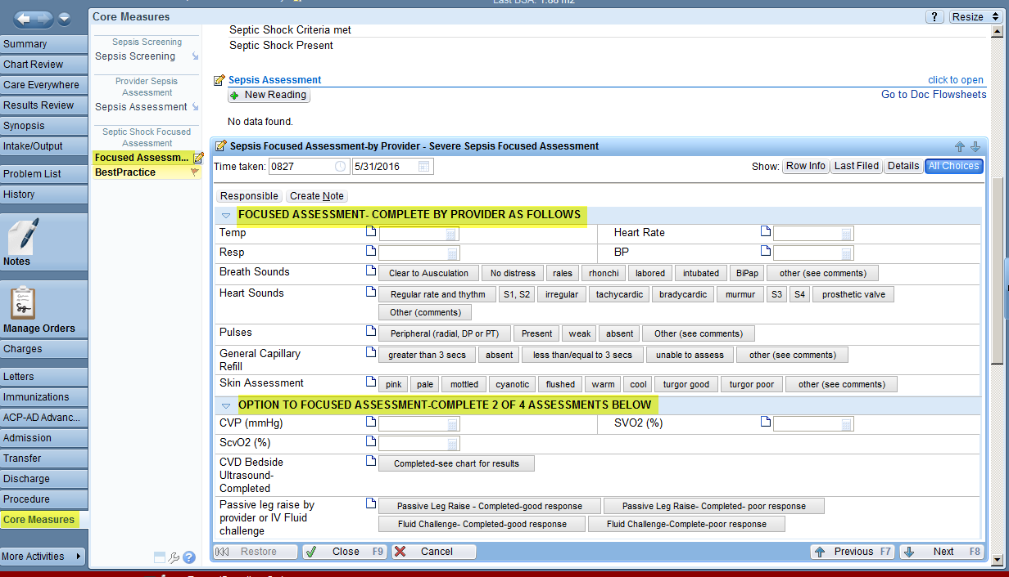
- A focused exam including:
  - Vital signs review
  - Cardiopulmonary exam
  - Capillary refill evaluation
  - Skin examination
- Any 2 of the following four:
  - Central venous pressure measurement (CVP or right atrial pressure)
  - Central venous oxygen measurement (SVO2, ScvO2 or oxygen saturation via central catheter)
  - Bedside Cardiovascular Ultrasound (Echocardiogram complete (also known as TTE, trans-thoracic echo, 2D Echo, Doppler), Echocardiogram Transesophageal (also known as TEE)
  - Passive leg raise exam or fluid challenge given.
Using Core Measure Sepsis Navigator – the provider may complete either section to meet the requirements. Sepsis Navigator Activity found in the Core Measure Navigator- Sepsis Focused Assessment Section

Once complete this information can be placed into a progress note using the smartphrase: .sepsisfocused
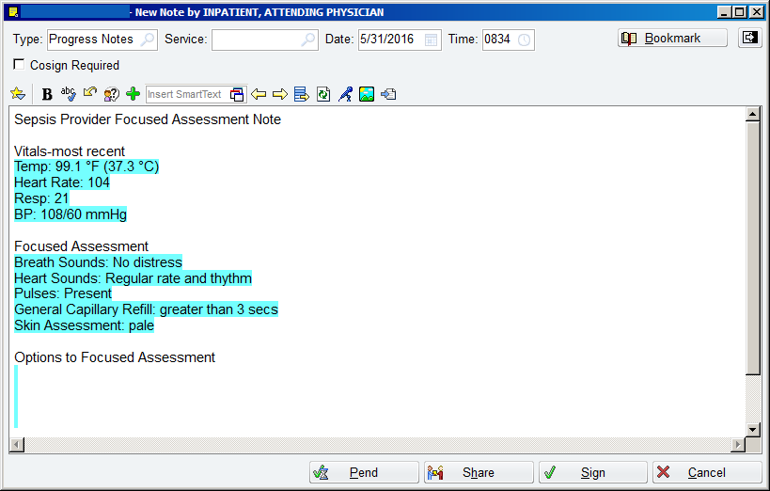

Provider documents patient care and considers need to add sepsis documentation which is available using the smartphrase: .sepsisbundlenote
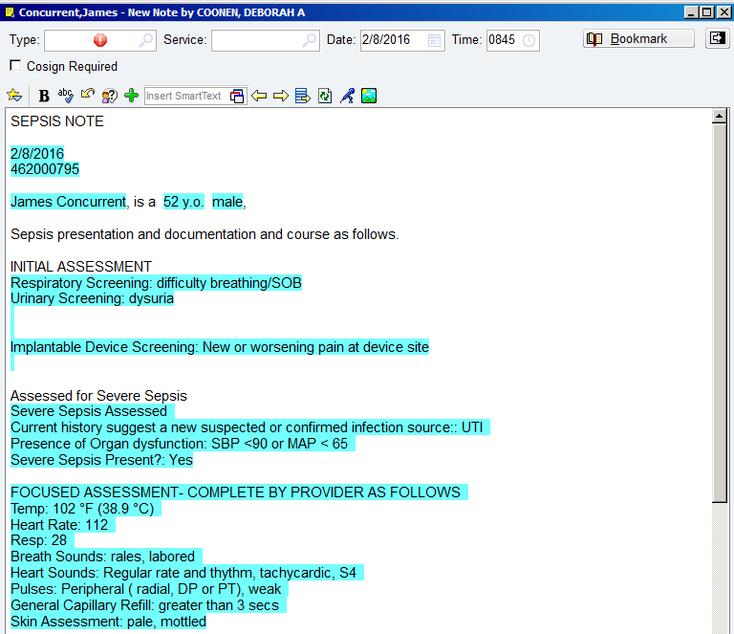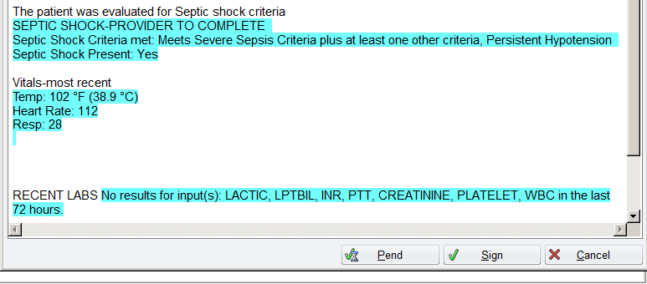.sepsisbundlenote smartphrase
Nurse carries out orders, monitors blood pressures notifying provider as appropriate. Care continues as needed by patient response.

Providers can utilize reports to review patient progress:
The Sepsis Overview report contains several widgets including patient medications, vital signs, select labs and imaging:
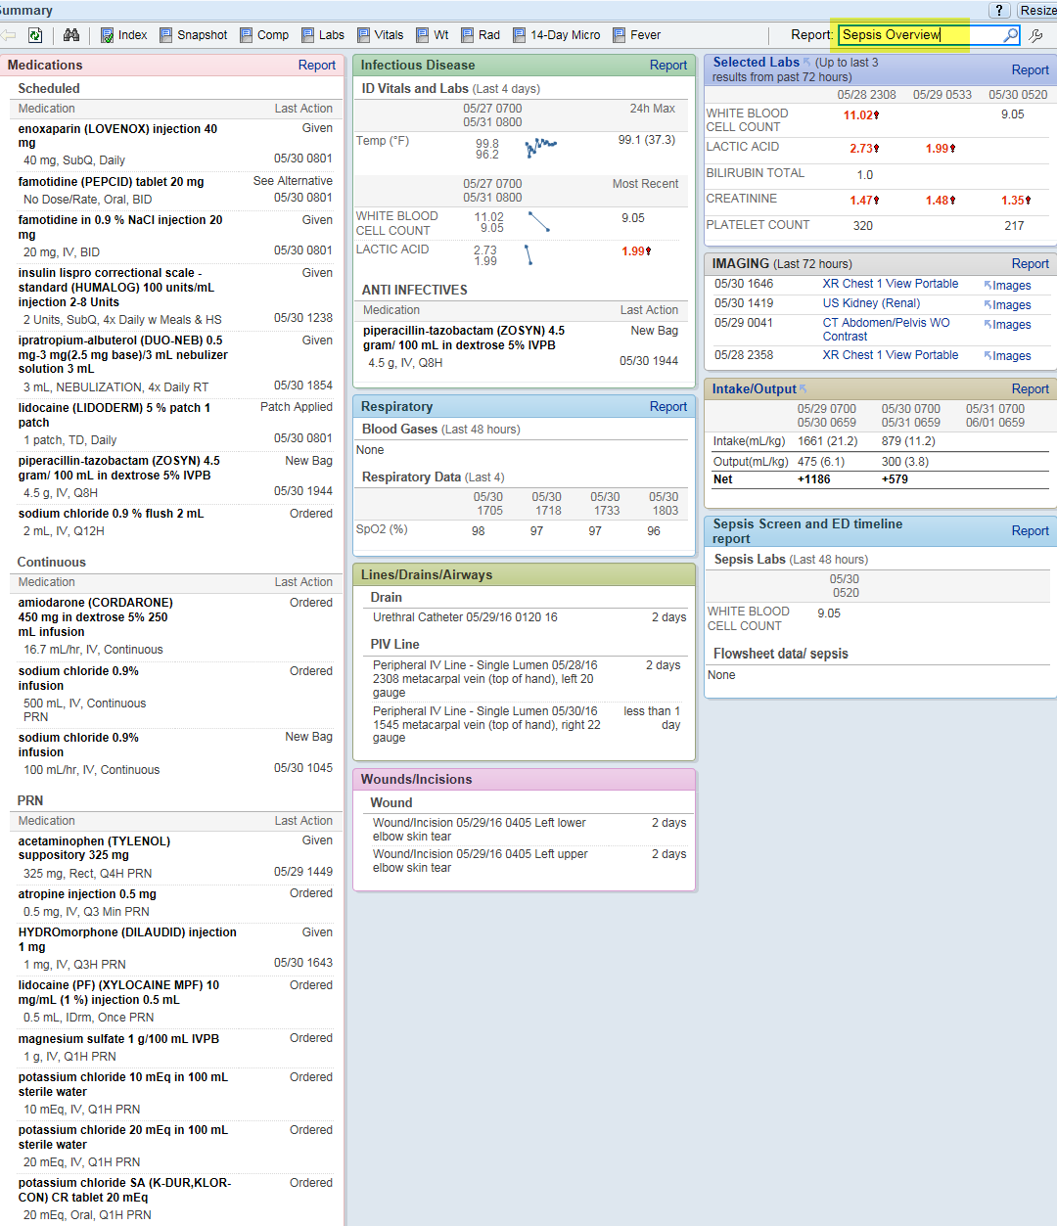Sepsis Overview Report
The Sepsis Accordion report will display a temperature graph along with the grid of all vital sign recordings, labs including: WBC, Lactic Acid, Platelet, INR< PTT< Creatinine, Bilirubin; administrations of anti-infectives, infusions, IVs and antipyretics.
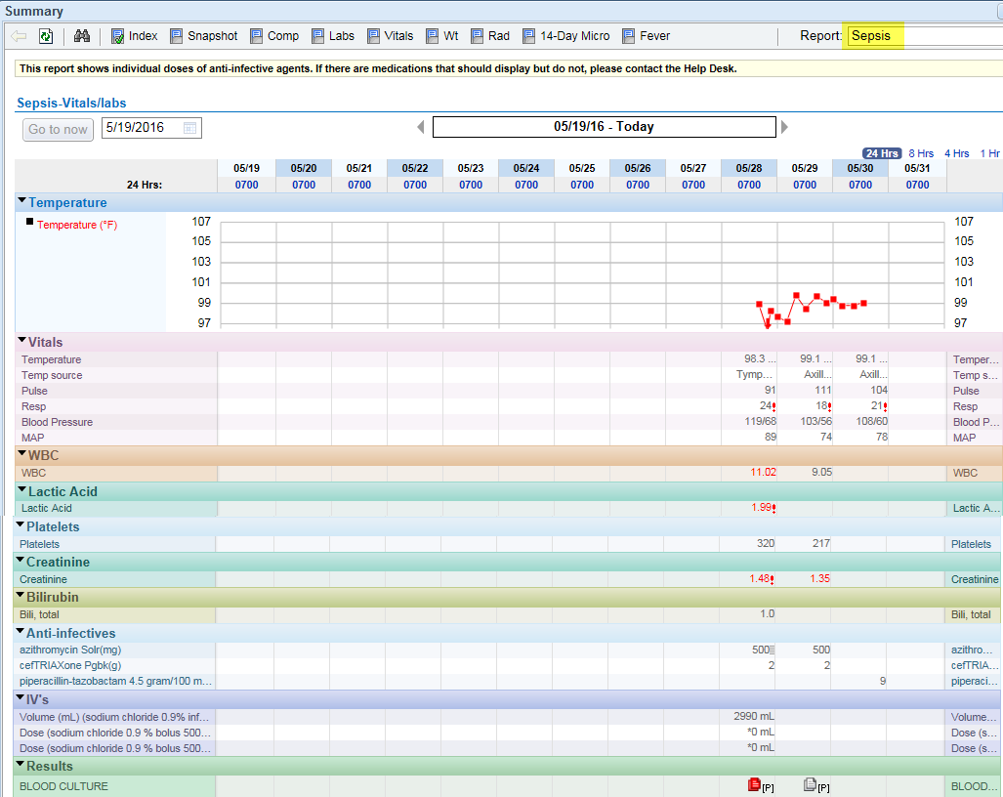Sepsis Accordion Report

Inpatient Workflow
Patient admitted to inpatient unit from the ED with Sepsis.
Patients presenting with severe sepsis /septic shock must receive timely treatment (within 3 hours of presentation):
- Lactic Acid Level obtained
- Blood cultures (prior to starting IV antibiotics)
- IV Antibiotics administered
- Crystalloid Fluid bolus (30mL/kg normal saline or lactated ringers) if hypotension* present or initial lactic acid > 4
And (within 6 hours of presentation):
- Repeat lactic acid (if initial level > 2)
- Crystalloid Fluid bolus (30mL/kg normal saline or lactated ringers) if not already administered
- Vasopressors for those with septic shock if they exhibit persistent hypotension** following fluid bolus
  - Patients started on vasopressors require documentation of repeat volume status and tissue perfusion. The documentation may consist of either:
- A focused exam including:
  - Vital signs review
  - Cardiopulmonary exam
  - Capillary refill evaluation
  - Skin examination
- Any 2 of the following four:
  - Central venous pressure measurement (CVP or right atrial pressure)
  - Central venous oxygen measurement (SVO2, ScvO2 or oxygen saturation via central catheter)
  - Bedside Cardiovascular Ultrasound (Echocardiogram complete (also known as TTE, trans-thoracic echo, 2D Echo, Doppler), Echocardiogram Transesophageal (also known as TEE)
  - Passive leg raise exam or fluid challenge given.
(Note: excludes patients who refuse treatment or are comfort measures only)

Patient arrives on unit:
ED provider handoff to attending provider, sharing patient admission details, status and course of treatment. ED nurse receives handoff of current treatment provided. The nurse or provider can utilize reports to review patient progress:
The Sepsis Overview report contains several widgets including patient medications, vital signs, select labs and imaging:
Sepsis Overview Report

The Sepsis Accordion report will display a temperature graph along with the grid of all vital sign recordings, labs including: WBC, Lactic Acid, Platelet, INR< PTT< Creatinine, Bilirubin; administrations of anti-infectives, infusions, IVs and antipyretics.
Sepsis Accordion Report
The nurse when admitting the patient and reviewing the Core Measure section of the Admission Navigator may notice Severe Sepsis present marked as Yes and the nurse can document that Septic Shock is also present.
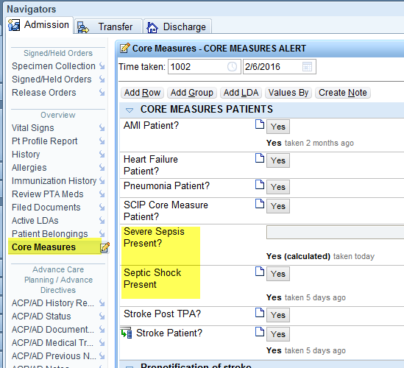 Admission Navigator, Core Measure Section
Nurse receives BPA in Admission or Shift Navigators and upon chart opening offering reminders of the treatment required in the first 3 and 6 hours after Severe Sepsis or Septic Shock has been identified.
The 3 hour alert displays to nurses and nursing students if the following conditions are present: Severe Sepsis Present has been marked “Yes” within the past 2 hours and the patient does not have current Sepsis CPG applied. If the nurse does not add the Sepsis CPG the alert will continue to fire for each nurse or nursing student until it is applied.
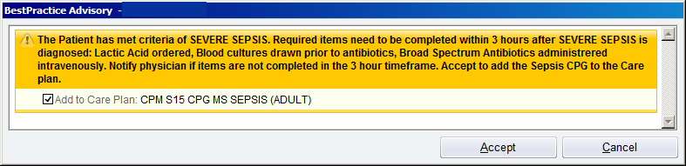 BPA IP Sepsis 3hr CM Alert
The 6 hour alert displays to nurses and nursing students if the following condition is present: Septic Shock Present has been marked “Yes” within the past 2 hours. Acknowledging the alert will suppress it for the current user for the remainder of the hospital stay.
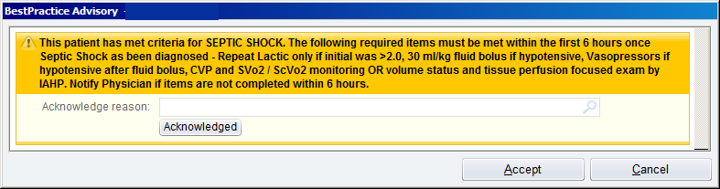 BPA IP 6hrs Sepsis Alert
The Provider receives BPA upon chart opening offering reminders of the treatment required in the first 3 and 6 hours after Severe Sepsis or Septic Shock has been identified. Acknowledging the alert will suppress it for the current user for the remainder of the hospital stay.
The 3 hour alert will display to providers (MD, PAs, and NPs) and medical students, if the Severe Sepsis Present has been marked “Yes” within the past 2 hours. Acknowledging the alert by selecting “Noted” will suppress it for the current user for the remainder of the hospital stay.
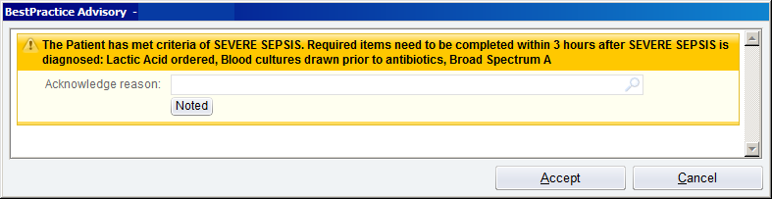 BPA Sepsis 3hr Physician Alert
The 6 hour alert displays to providers, PAs, NPs and medical students if the following condition is present: Septic Shock Present has been marked “Yes” within the past 2 hours. Acknowledging the alert will suppress it for the current user for the remainder of the hospital stay.
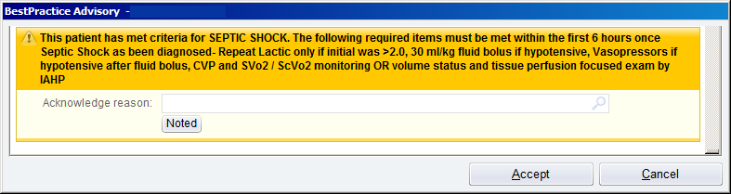 BPA Sepsis 6hr Physician Alert
The provider determines appropriate treatment in admission navigator adds Severe Sepsis or Septic Shock to patient problem list. Reviews patient current orders, reviews and reconciles home medications then adds appropriate orders from the Severe Sepsis/Septic Shock Admission order set based on patient needs:
Treating for Severe Sepsis Only
- Is patient hypotensive?
- Did patient receive 30 ml/kg bolus? If not order and assess response, watch for possible decline resulting in Septic Shock and need for Vasopressors (Sepsis Initiate Vasopressor Order Set). If vasopressors required must document repeat volume status and tissue perfusion assessment.
Treating for Severe Sepsis with Septic Shock
- Was initial lactate >4, patient will have repeat lactate order activated by nursing.
- Assure completion of 30ml/kg bolus.
- Assess for need of vasopressors. If vasopressors required must document repeat volume status and tissue perfusion assessment.
Provider documents Admission H&P and considers need to add sepsis documentation which is available using the smartphrase: .sepsisbundle
.sepsisbundle smartphrase
Nurse carries out orders, monitors blood pressures notifying provider as appropriate. Care continues as needed by patient response.

Abstractors Workflow
Receive list of patients from Truven
Access patient record in Epic; utilize a paper form to document findings as each chart section is reviewed
Utilize chart review to review applicable areas:
Lab results
Med History
Notes
Flowsheets – Sepsis Documentation
Use the Core Measure Navigator, Sepsis Activity to view information documented by providers/nursing.
Based on findings completes required information in Truven

